**SAD TUTORIAL**

**WEEK 06 – SEQUENCE DIAGRAM**

*\* Write all your answers in a word document and submit your work to the submission box.*

**Review question:**

1. What does a sequence diagram show you?
2. Name the four numbered elements in this diagram:

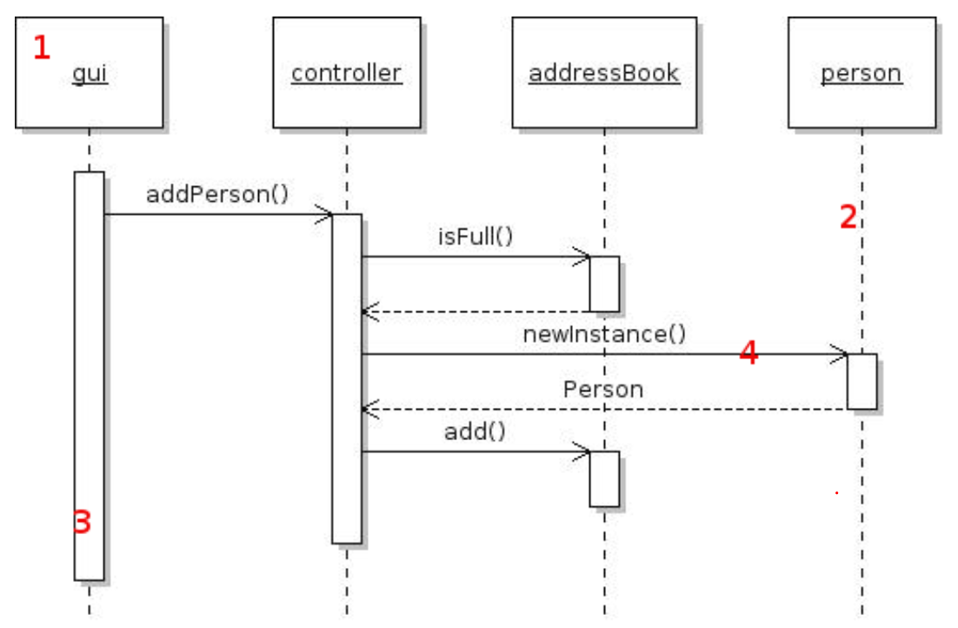

**EXERCISES**

1. **Draw a sequence diagram for the situation when one Student Login to Fit Portal**
   1. List step by step to implement the function in your own words
   2. Draw the diagram
      1. Make sure your diagram clearly shows which objects are in this process
      2. Objects that you must include are
      * Student
      * Login Pages
      * Home Pages
      * Account Controller
      * Student Entity
      1. You can include other objects if you need them to make your diagram clearly
2. **Draw a sequence diagram for creating new account at https://chieuphimquocgia.com.vn/register**
   1. List step by step to implement the function in your own words
   2. Draw the diagram
      1. Make sure your diagram clearly shows which objects are created when customer register for a new account
      2. The order in which objects are created or invoked is important.
      3. Objects that you must include are
      * Customer
      * Register Pages,
      * Home Pages,
      * Customer Controller
      * Customer Entity
      1. You can include other objects if you need them to make your diagram clearly
3. **Draw a sequence diagram for forgot password process**
   1. Make sure your diagram clearly shows which objects are in this process
   2. You can include other objects
4. **Pick up at least 3 use cases in this use case diagram bellow to draw sequence diagram**

